CMR TECHNICAL CAMPUS

UGC AUTONOMOUS
Accredited by NBA & NAAC with ‘A’ Grade
Approved by AICTE, New Delhi and JNTU Hyderabad

Department of Computer Science and Engineering
TITTLE

Cervical cancer is a leading cause of death among women, making early detection essential. This project, “Cervical Cancer Prediction and Classification Using Deep Learning on Medical Image Data,” uses the Xception deep learning model to classify cervical cell images into seven categories from the Herlev dataset (17,304 images).Built with Python, Flask, HTML, CSS, and JavaScript, the system achieved 93% training and validation accuracy. It provides an automated, reliable tool to support pathologists, improve diagnostic accuracy, and enable faster cervical cancer screening.

  A Novel Web-Based Framework for Cervical Cancer Detection Using Advanced Machine Learning Techniques” is an intelligent healthcare system designed to assist in the early detection of cervical cancer through automated machine learning models integrated into a web platform.Cervical cancer is one of the leading causes of cancer-related deaths among women worldwide. Early diagnosis significantly increases survival rates. However, traditional diagnosis methods rely heavily on manual examination of Pap smear images, which can be time-consuming, subjective, and prone to human error.To overcome these limitations, this project proposes a web-based detection framework that uses advanced machine learning algorithms to analyze cervical cell data and predict cancer stages accurately. | 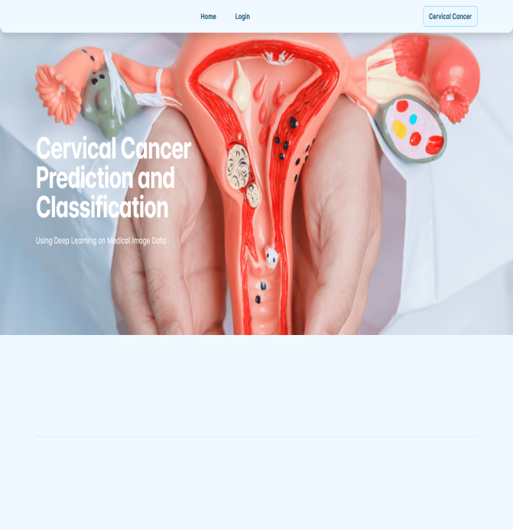
 | Batch-11:  K. ARCHANA 247R1A0596  V.YASHWANTH 247R1A05C6  P.LAKSHMI 247R5A0532  FACULTY SUPERVISOR  - Sai Krishna  AssistantProfessor.
- Web-Based Expert System (WFC2DS)
- Ensemble Machine Learning Algorithms
3. UCI Numerical Patient Dataset
- Biopsy as Target Variable
- Data-Driven Clinical Decision Support
This project develops a deep learning–based system for cervical cancer classification using the Xception model and the Herlev dataset. The model achieved 93% accuracy, demonstrating reliable performance across seven classes. Built with Python, Flask, HTML, CSS, and JavaScript, it provides an automated tool to support early diagnosis and assist healthcare professionals. Future improvements include using larger datasets, integrating clinical data, applying explainable AI, and enabling real-time clinical deployment.

